***Deep learning report 1***

Nour Ahmed Aboelmagd 20176033

***Deep Learning Report***

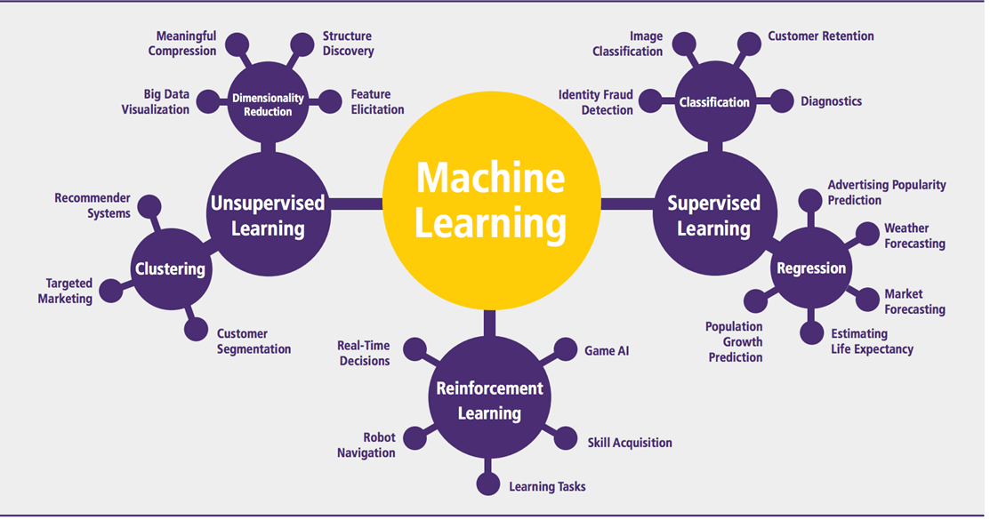

**Week 1:**

**Neural networks:**

It consists of a neuron or multiple neurons with inputs and outputs and the size of it depends on the number of neurons

**simple neural network:** consists of one neuron

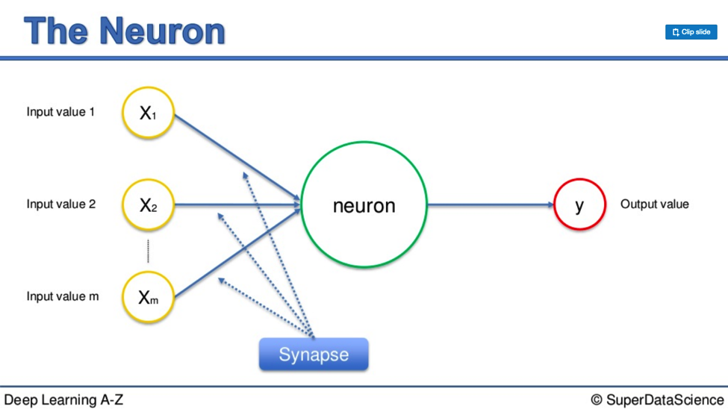

**complex neural network:** consists of multiple neurons

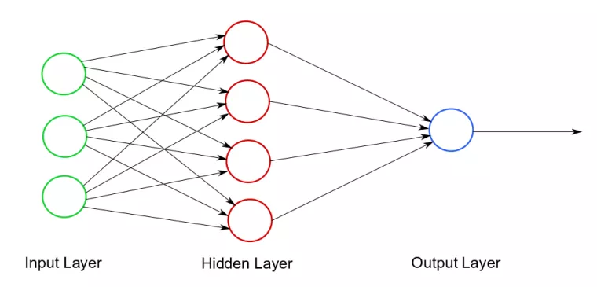

A neural network consists of:

* Input features
* Training sets
* Test sets
* Output

**Supervised learning:**

making the network learn and handle a new function by dealing with previous experiences

**Types of neural networks:**

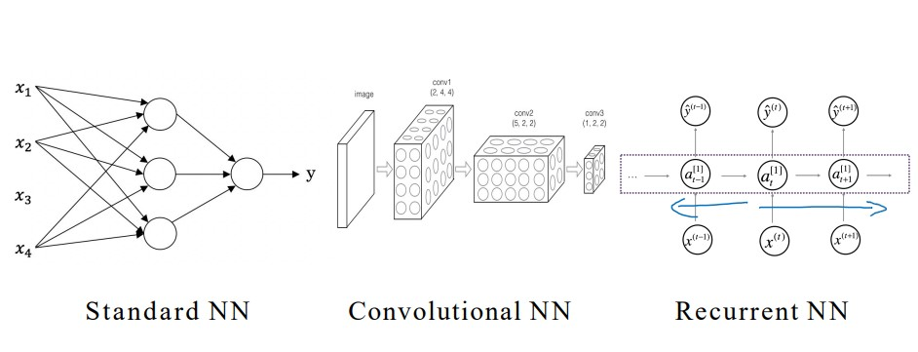

**Types of Data:**

* Structured: databases
* Unstructured: photos – audio – text

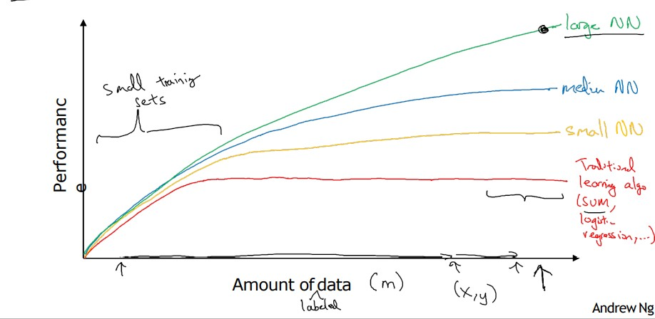

With the continuous increase in data acquired, increase in neural network size and training sets is mandatory to adapt

Also, using more data leads to faster computation process

**Cycle of deep learning:**

**Week 2:**

Supervised learning is divided into:

* Regression (one output either zero or one)
* Classification (multiple outputs divided into classes)

**Binary classification:**

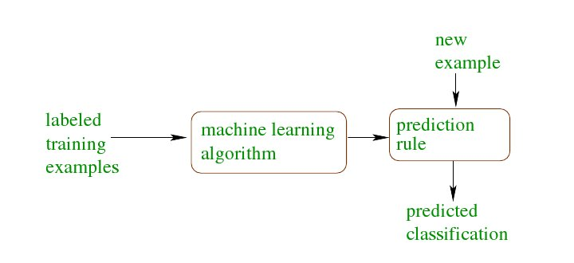

RGB matrcies are unrowed into vector (x) which are the dimensions of the input features, normally it is equal to (64*64*3=12288)

**Logistic Regression:**

Where the output is either Zero or one and we estimate the result by using the activation function (Sigmoid)

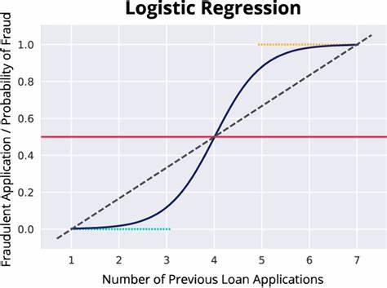

**Loss function:**

Computes the error in one training example

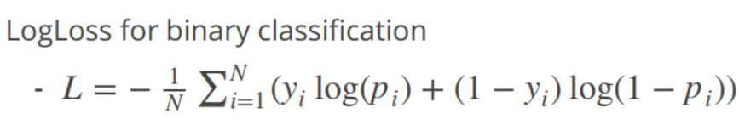

**Cost function:**

Computes the average of error in the entire training set



**Gradient Descent:**

In order to compute the parameters (w,b) , gradient descent with the goal in mind is to minimize the value of the cost function as possible

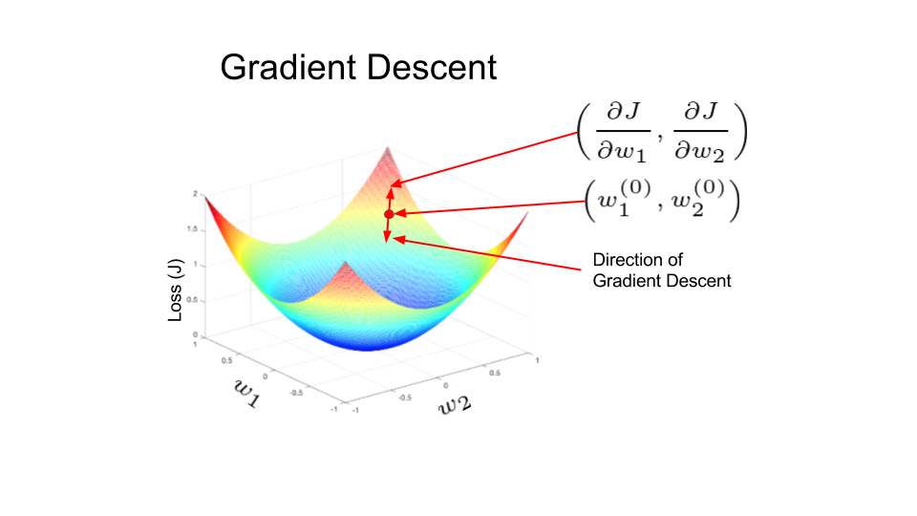

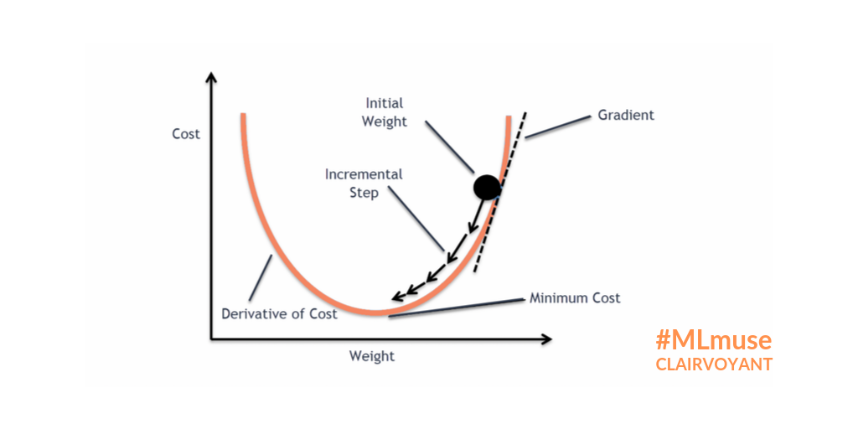

-As b is assumed to be zero, the graph turns into a 2D one

-First w is initialized as a certain value, then it is updated until the global optimum is found

-The update of (w) is performed by the learning rate changing

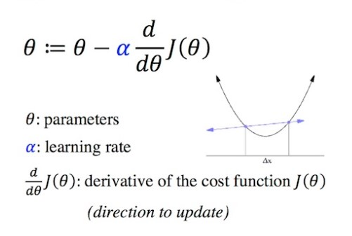

**Backward propagation in computation graph:**

In order to update the parameters (w, b), we have to deduce the derivative by backward propagation

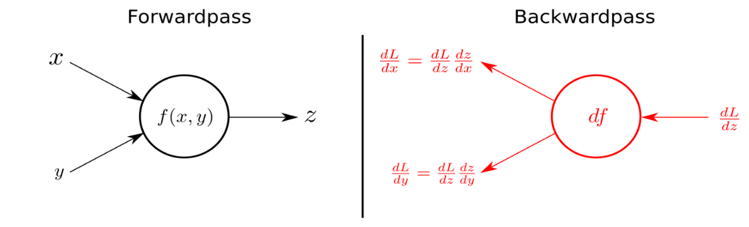

**Vectorization:**

Vectorization is a method in deep learning implemented to nearly eliminate the use of the for loop for faster computation by replacing it with one line of code

For example: the training examples (x1,x2,…, xm) are all accumulated into one vector training set X

**Broadcasting:**

When matricies are multiplied it was supposed that the number of columns in first matrix is equal to the number of columns in the second matrix but python solves this problem with the condition that either the number of rows or columns is the same in both matricies

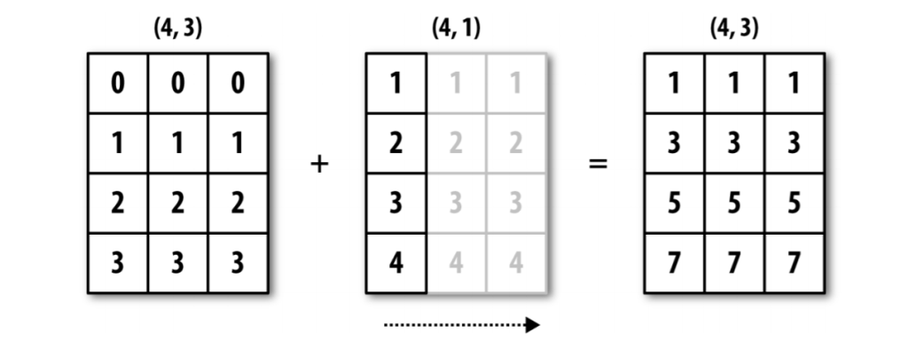

**Week 3:**

**Neural Network presentation:**

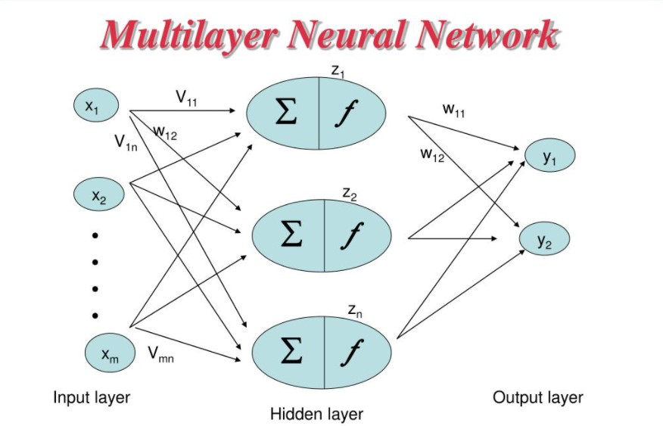

Neural network is divided into multiple layers which are:

1. Input layer
2. Hidden layers
3. Output layer

* Input layers has the input features each one is connected to every neuron in the hidden layer next
* In the hidden layers, each neuron computes a linear function followed by the activation function
* Output layer computes the estimation of the output

**vectorization:**

each layer has its content vectorized like the weights of first hidden layer (W1)

**Types of activation functions:**

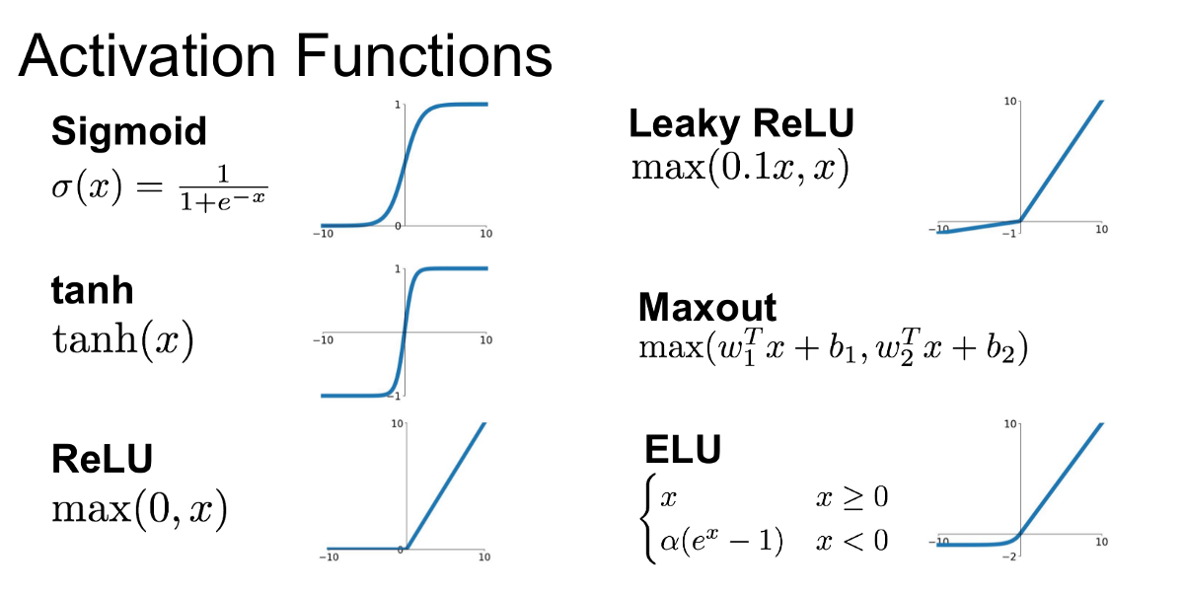

Non linear activation functions such as tanh has a great advantage in that the functions vary from (-1,1) by making zero the mean which enables easier learning experience where if linear function is used, the output will be the linear function of input which is basically nothing

But in output layer the sigmoid can be used because there is only one output which makes the learning part already limited

**Random initialization:**

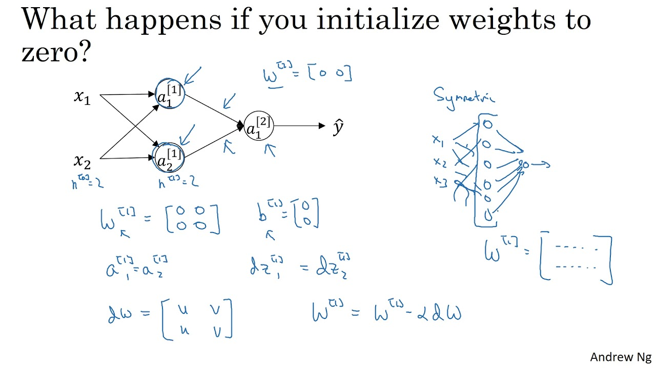

The initialization of bias (b) is fine to be zeroes but in weights its different

If weights are initialized by zero, each neuron in the hidden layer will compute the same and after iterations of gradient descent and updating it will still be the same

This problem is called (break symmetry) and it stalls the learning process without an end

So, weights must be initialized with random variables

But must be small values for the gradient descent to be small to continue learning in the area where the slopes vary for better learning and faster optimization